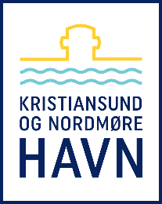
WASTE FORM
KRISTIANSUND AND NORDMØRE PORT AUTHORITY

VESSEL INFORMATION
NAME OF SHIP: | GROSS TONNAGE:
ETA PORT: | ETD PORT:
REQUESTED BERTH: | ORDERED BY:
NAME OF AGENT: | INVOICE TO:

NO SPESIAL FEE | Type | Kg/m3
 | Mixed waste
 | Mixed crushed glass
 | Crushed aluminium cans
 | Crushed steel/tin cans
 | Cardboard-paper
 | Plastic materials
 | Pallets-wood waste
 | Electronics and batteries
 | Galley waste (produced in Norway only)
 | Paint, glue and varnish

SPESIAL FEE | Type | Litres/m3 (amount) | Connection hose dimension
 | Sludge and oily water
 | Grey and black water
 | Oil rags
 | Food waste Cat. 1 (from ships in international traffic)

Contact information:
Port of Kristiansund and Nordmøre IMC
Astrups gate 9, NO-6509 Kristiansund, Norway
Phone: + 47 992 99 120
E-mail: havnevakt@knhavn.no
Web: www.knhavn.no

